
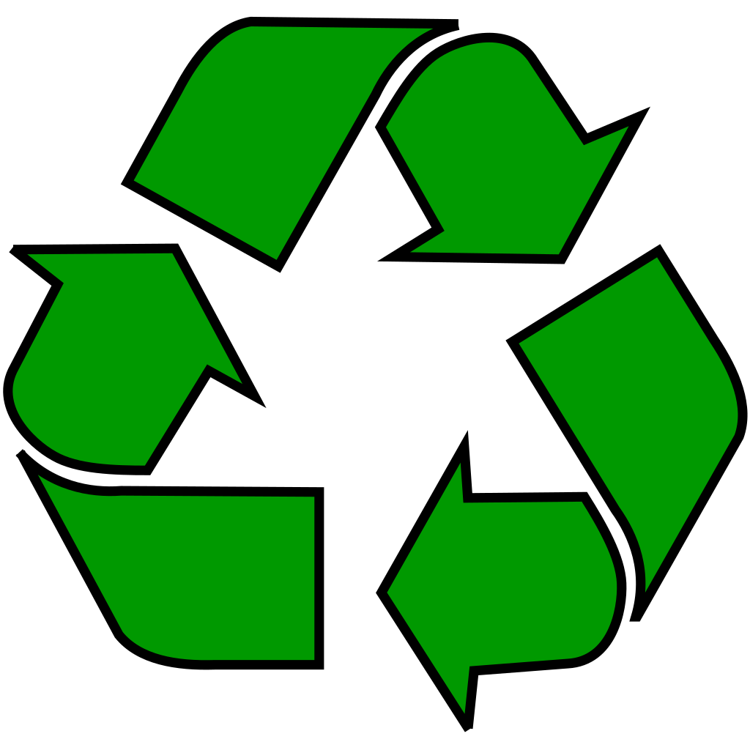
recycle right 2021

Garfield Heights Service Garage
13600 McCracken Blvd.

Household Hazardous Waste Collection

Sept. 7 – 10
Sept. 13 – 17
7:30 a.m. to 3 p.m.

Sept. 18
9 a.m. to Noon

Free Document Shredding
(Limit FOUR bags/boxes per vehicle)

Sept. 18
9 a.m. to Noon

Residents only.
No commercial disposal.
For details call 216-475-3373.




